Reference images for the Roman letters
https://www.goines.net/acra_book/acra_content/files/text_a.html

Hotkeys
Space Bar = Toggle 1 / 4 panel view (select view)
Insert Key; Home Key (Mac) = Move origin
W = Move
E = Rotate
R = Scale
F = Frame the selected object

The Workspace
- The panel with a preview of the scene you are working in is called the “Preview Window”. The top is the “Menu Bar”. To the right are the Channel Box/Layer tab, Modeling Toolkit tab, and the Attribute Editor tabs. At the bottom is the “Timeline”You can show or hide them by clicking the buttons at the top right.
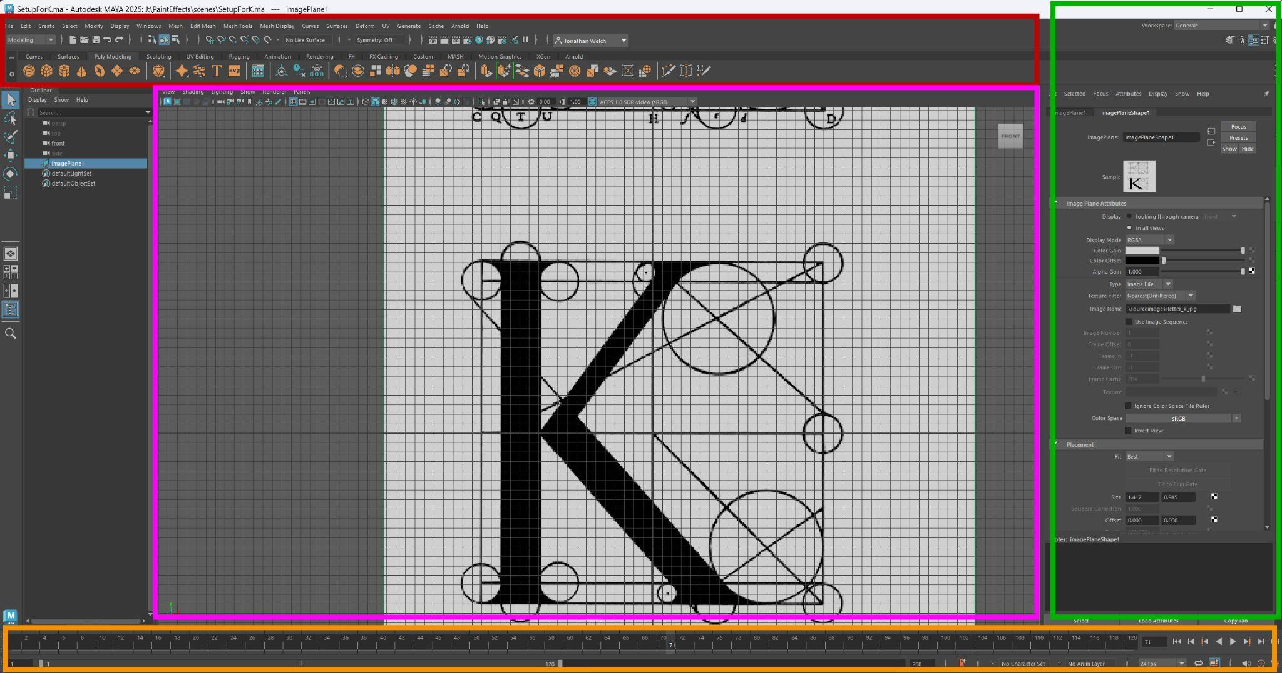
- Make Sure you are in the Modeling Tool Kit (Upper Left drop down menu)
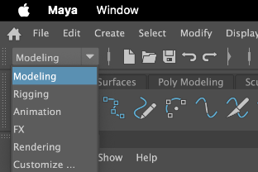
and the “General” Workspace (Top right drop-down menu
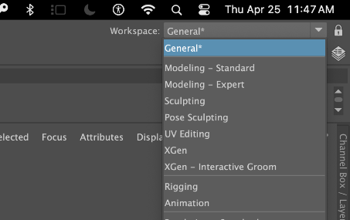
- Open the File PaintCurveStart#.ma (replace “#” with the letter you would like to use)
I have already added an image to the image plane of the orthographic “Front Camera”.
You can switch cameras by hovering over the preview window and hitting the spacebar. That toggles between the 4 panel view (Front Camera, Top Camera, Side Camera, and Perspective Camera). Hovering over one of the preview windows in the 4 panel view and Hitting Spacebar again switches to the single view for the view you are hovering over.
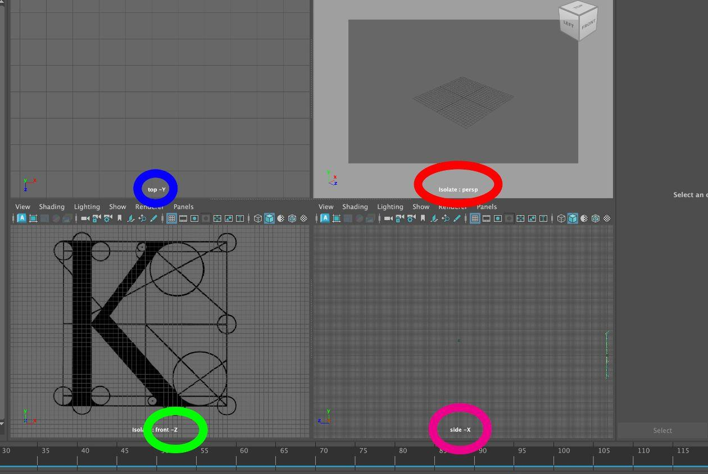
- If you wanted to add an image you could go to View (upper left of the preview window) > Image Plane > Import Image
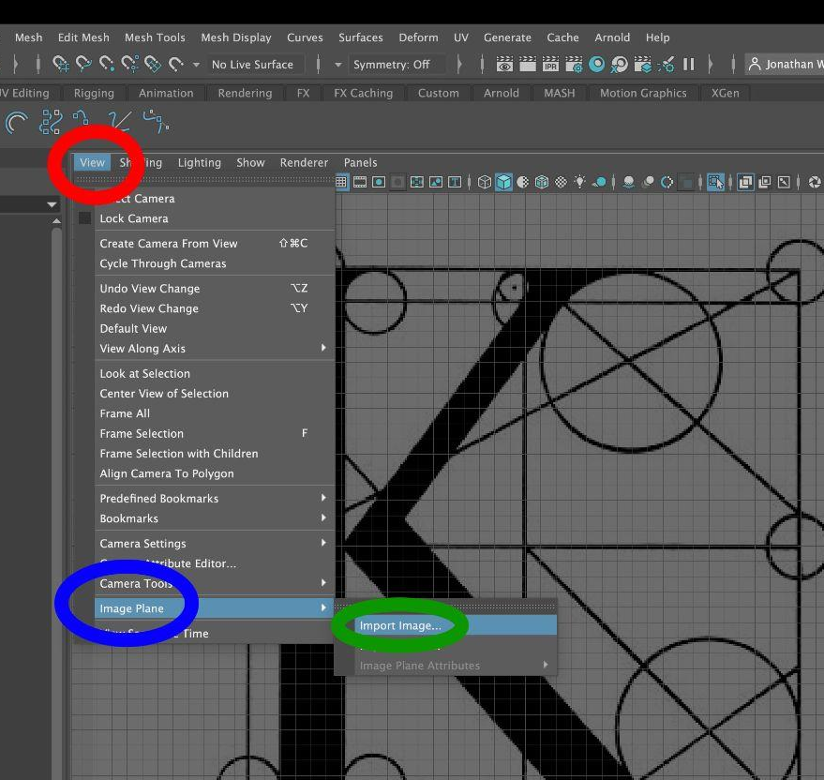
Creating a Path with the Curve Tool
- Go to Create (top left menu) > Curve Tool > Bezier Curve Tool
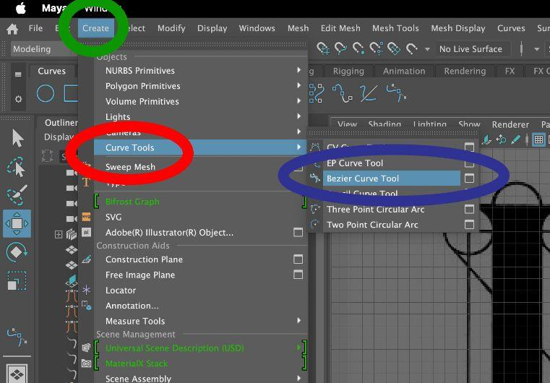
- Trace the curves of your letter
- Once you have a rough curve click the selection tool (left side of the screen near the top)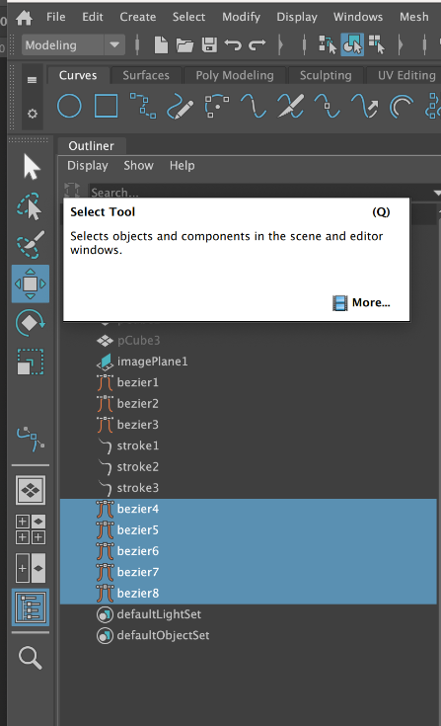
Right click on the curve to “Control Vertex” (if you are getting a different set of options that are about the image, it is because mMaya thinks you are selecting the ImagePlane object; You can make it a reference layer in the Channel Box/ Layer Editor if the issue gets frustrating)
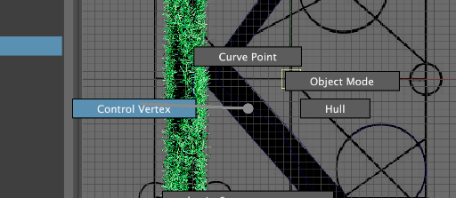
- Move the curve handles and vertices around to match your diagram’s contours
- Change the menu bar set to Effects with the drop down menu on the upper left
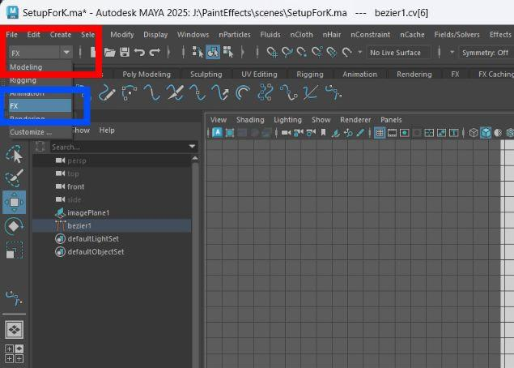
- Go to Effects (at the top/middle and “Get Effects Asset” to pull up the effects content browser
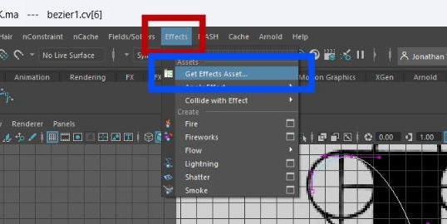
There are a lot of fun effects to choose from, I am going to start with a grass. Under Paint Effects > Grasses > Astroturf.mel
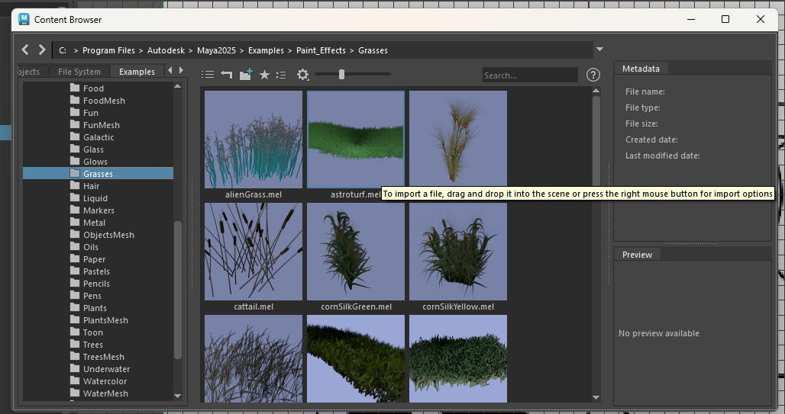
- When you click on the preview image, a blue outline appears to let you know this is the effect you have selected. Leave the Effects Content Browser up, but move it to the side.
- Go back to the Modeling menu bar (drop down window in the upper left; see step 10).
- Pick the selection tool from the panel on the left
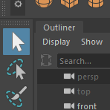
- Select the curve.
It should change from dark blue to cyan in the outliner and it will be highlighted in the outliner. You can also use the outliner to select the curves. It is good policy to rename things in the outliner so you can select and find them in the preview window.
- Select the curve in the Outliner and rename it “ K_Curve_1 or something that will make it easier to find. Then click in the preview window and hit “F”. The selected object will be centered in the preview window.
- Hover over the preview window and hit space bar. This will go from the single plane view to the 4 pannel view. Hover over the front view window and hit space bar to go back to the front view. you can change the preview windows individually by Clicking “panels > and selecting the orthographic or perspective view you want to look through.
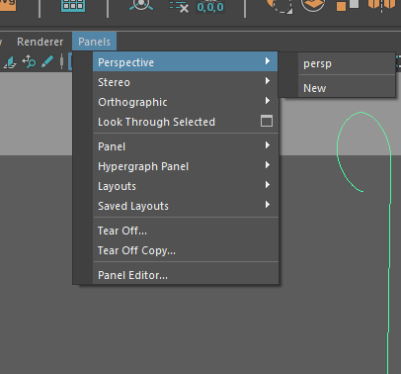
- With the curve selected go to Generate > Curve Utilities > Attach Brush to Curve
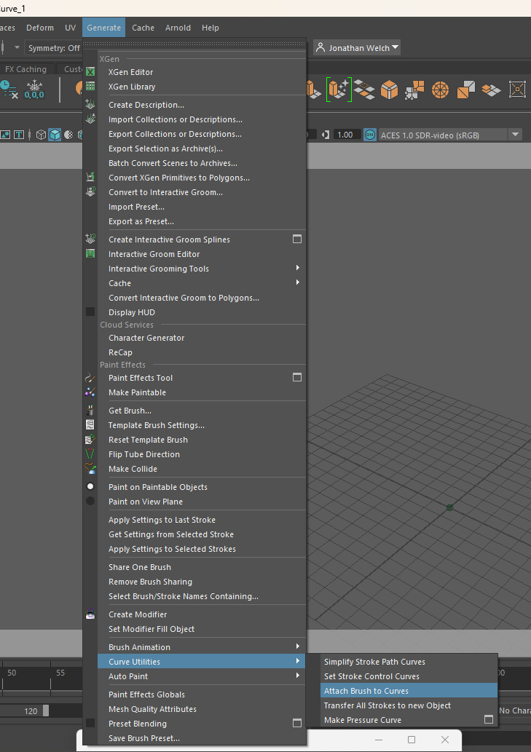
Tuning the Effect
Now we need to tune the effect. In Maya the default size of a square on the gris should be 1 cm, but for some reason that doesn’t apply to paint effects, so we have to change it so something we think looks the right scale.
- In the attribute editor, under the effect (astroturf2 in my example) I am going to change the global scale to 5 and the Brush Width to 0 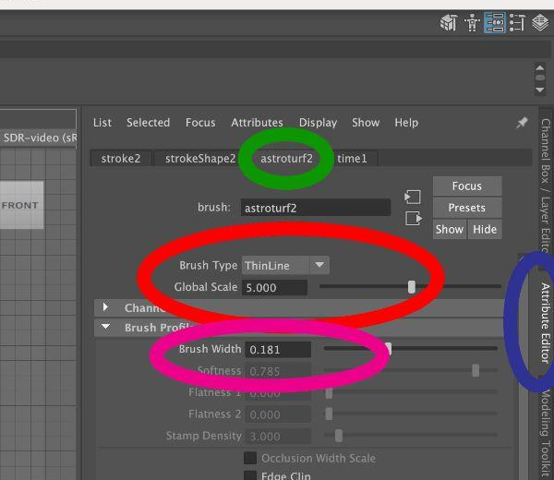
- Then I am going to go to the strokeShape (also under the attribute editor), make sure “Use Normal'' is selected, and change the normal direction to X = 0, Y = 1, Z = 1. The normal direction is the direction perpendicular to the surface. Like a flagpole is perpendicular to the ground. In this case, I want the grass to grow out (away from the wall) and up. It is defined by 3 degrees of rotation.
- I want the strokes to be more broad so that it doesn’t look so much like a pipe cleaner so Under the “Astroturf” (or whatever the name of stroke you have applied) I change the “Brush Type” to paint, and I adjust the “width” to blur the edges..

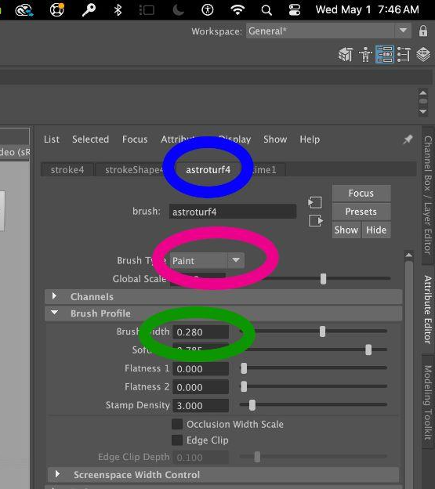
- Then I do the same for all the strokes.
- I want this to be an animation so I go to the “Stroke Shape” tab and adjust the Endbounds. The “Max Clip” is the end, and the “Min Clip” is the beginning.
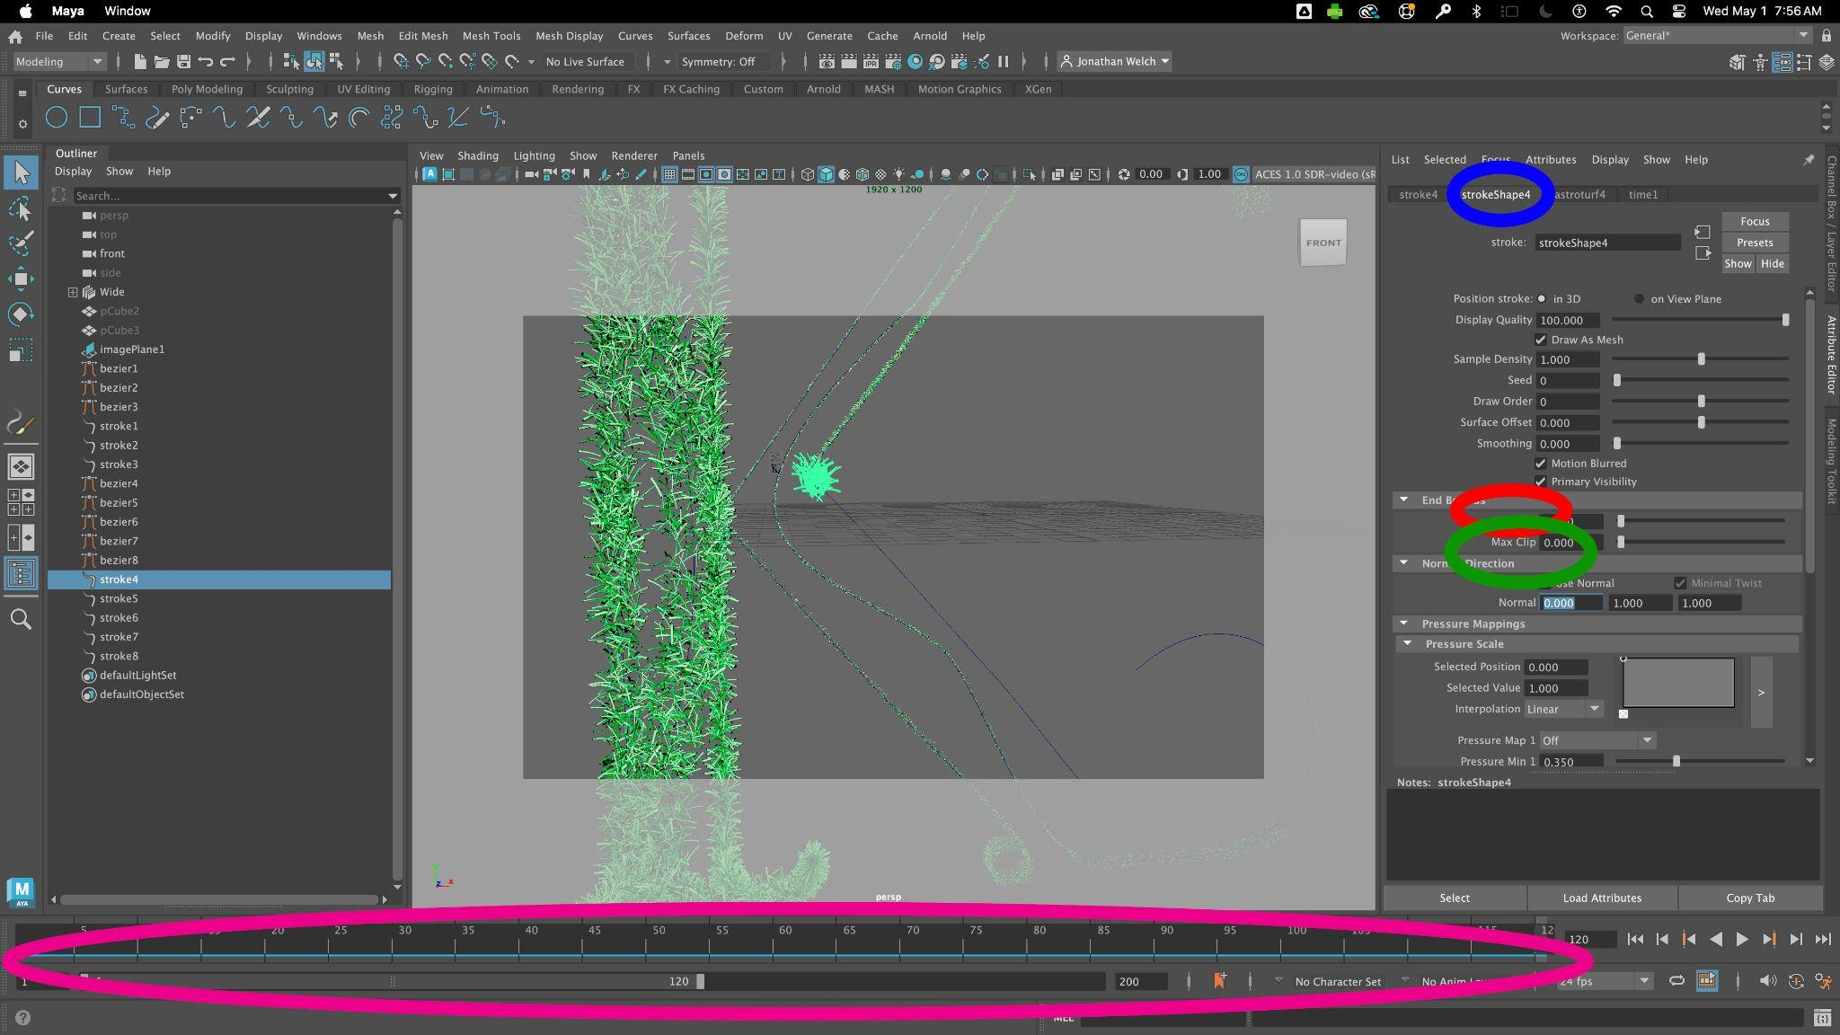
- Go to the Timeline (at the bottom of the screen), and make sure the “Current Frame” Lightly Highlighted and numbered in white is set to “1”
- Go back to the “Max Clip, and right click on the word to select “Set Key”
- Then Move the “Time Slider” to 120, Set the Max Clip to 1, and set the keyframe again
- Do the same for all the strokes. There are many more settings and other procedurally generated effects to play with.
Converting the Strokes to Polygons (Optional)
If you are using Arnold or one of the better render engines or you want to have your effect cast shadows you have to convert the effect to polygons.
- Go to the Outliner, select all the strokes
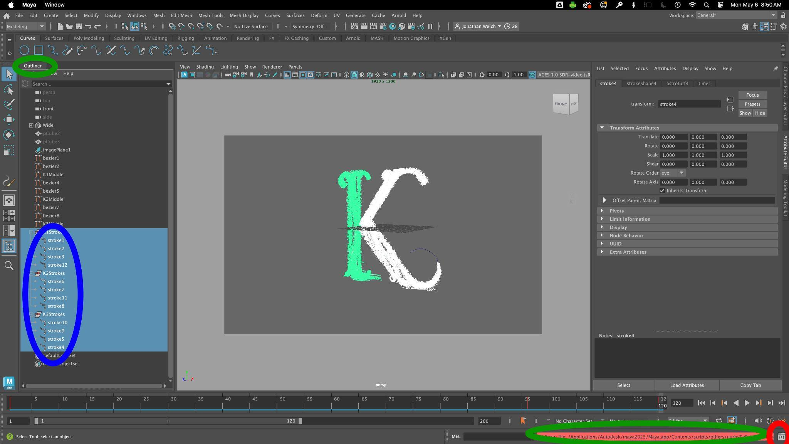
- Go to Modify (top left menu)> Convert > Nurbs to Polygons
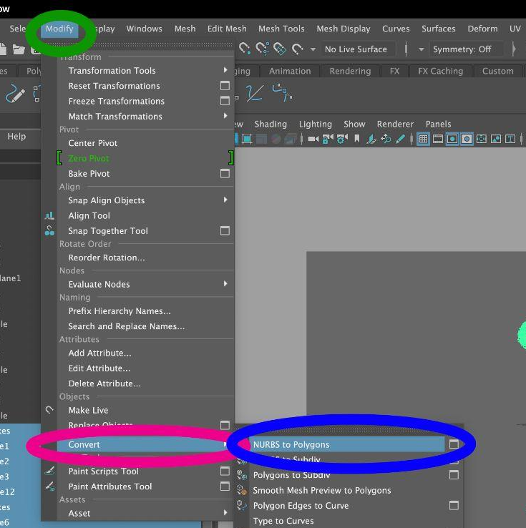
- *If you see a red warning at the bottom, you can view the details by clicking the Script Editor
Setting the Render Engine
- Click on the Clapper Board with an Eye on it (Do not click on the one without an eye just to the right, or it will render the selected preview window, and that can take a while if there is a lot in the scene). This will pull up the Render Settings Window.. Select the render engine you want to use (I am using Maya Software because it is simple and fast. Arnold looks much better, but the paint effects will need to be Polygons, and the lighting looks best if you are using the Arnold lighting and materials. ) Make sure you have the camera you want to render selected as the Renderable Camera. Set the image size to match your output (the native resolution of the projector)
- 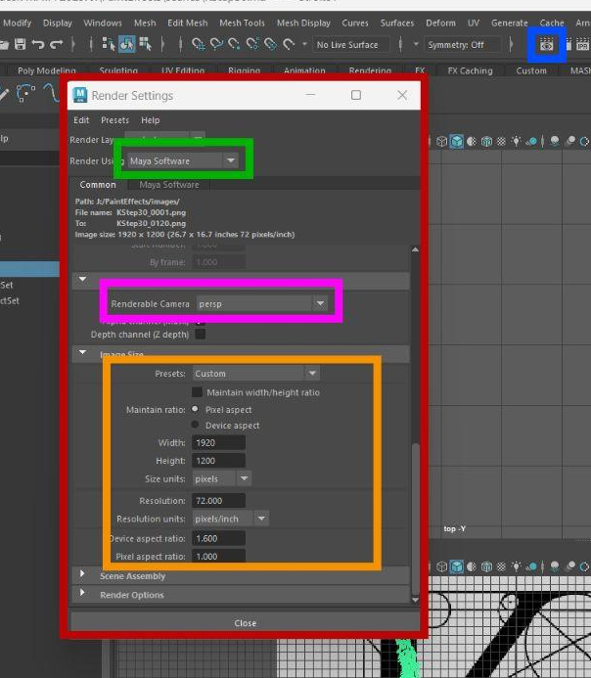
- Make the Image format png (I am using a png because it can have a transparent background and it is a smaller size, tiff is often preferred for mastering.) Set the frame range (I am going to make this 120 frames, that will be 5 seconds at 24 frames per second the frame rate and time settings are under Window (at the top) > Settings/Preferences > Preferences Then scroll down to Time Slider) Alternatively there is a time slider button in the lower right corner 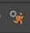. Change the naming convention to name_#.ext
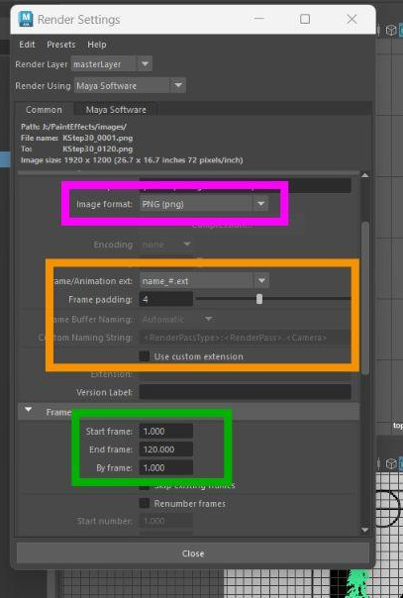
- If you want to cast shadows, you have to turn on Raytracing.
- Switch to the Rendering menu set. Go to Render (at the top) and select Batch Render
